**Netflix Business Analytics Report**

Project Title: Netflix Content Analysis: A Business Analytics Approach

Submitted by: R. Monesh Raja

**1.Summary:**

Netflix is one of the leading streaming platforms globally, providing a vast collection of movies and TV series across different genres. This business analytics project aimed to analyze Netflix’s content library using Python for data preprocessing and Tableau for data analysis and advanced visualization.

**2. Introduction**

**2.1 Project Objective:**

The objective of this project is to analyze Netflix’s content structure, understand viewer preferences, and provide strategic recommendations for content acquisition and production.

**2.2 Business Problem Statement:**

Netflix faces challenges in balancing content quantity and quality while retaining viewer engagement. Understanding content distribution, user preferences, and rating trends can help in making data-driven decisions for better content strategy.

**2.3 Dataset Overview:**

The dataset consists of Netflix movies and TV shows, including attributes such as title, release year, genre, IMDb ratings, content type (Movie/TV Show), and more.

**2.4 Cleaning Process:**

* We performed several preprocessing steps using Python (Pandas & NumPy):
* Handled Missing Values: Filled missing IMDb ratings with the median and removed unnecessary null rows.
* Standardized Columns: Trimmed spaces and converted text to lowercase.
* Converted Data Types: Changed release_date to Date Time format for better analysis.
* Filtered Outliers: Removed incorrect release years (before 1900) and unusual IMDb ratings.

**2.5 Final Cleaned Data Summary:**

* Dataset Name: Netflix Movies & TV Shows Dataset
* Total Records: 8,790
* Movies: 6,400 (72.8%)
* TV Shows: 2,390 (27.2%)
* IMDb Ratings Range: 1.2 - 9.6
* Key Columns: Title, Release Year, Genre, IMDb Ratings, Content Type (Movie/TV Show)

**3.Methodology**

**3.1 Data Preprocessing (Using Python IDLE)**

* Handled Missing Values: Filled missing IMDb ratings with median values.
* Standardized Columns: Trimmed spaces and converted text to lowercase.
* Converted Data Types: Changed release_date to DateTime format.
* Filtered Outliers: Removed incorrect release years (before 1900) and unusual IMDb ratings.

**3.2 Data Analysis & Visualization (Using Tableau)**

Created interactive dashboards with the following key visuals:

**3.2.1 Top IMDb Rated Movies & TV Shows**

**[ Horizontal Bar chart]**

Breaking Bad (9.6), Band of Brothers (9.5), The Shawshank Redemption (9.3) are among the highest-rated.

**3.2.2 Movies vs. TV Shows [Vertical Bar chart]**

Netflix is heavily movie-focused (~73%), but TV shows have a strong audience base.

**3.2.3 Content Growth Over the Years [Line chart]**

Netflix expanded massively after 2010, with content release peaking in 2018-2021.

**3.2.4 Top 10 Popular Genres [Horizontal Bar chart]**

Comedy & Drama are the most common genres, each with 1,500+ titles.

**4. Key Insights**

1. Netflix is heavily movie-focused, with 72.8% of its content being movies and only 27.2% being TV series.
2. Top IMDb-rated content includes *Breaking Bad (9.6), Band of Brothers (9.5), and The Shawshank Redemption (9.3).*
3. Netflix’s content library expanded rapidly post-2010, with content releases peaking in 2018-2021.
4. Comedy & Drama are the most common genres, each having 1,500+ titles.
5. Majority of content has IMDb ratings between 5.5 - 8.5, suggesting a mix of quality but room for more high-rated content.

**5. Recommendations:**

* Leverage Top Genres: Netflix should invest more in Comedy & Drama while expanding niche high-rated genres like Crime & Thriller.
* Enhance TV Show Portfolio: TV shows tend to have higher IMDb ratings, making them essential for increasing long-term viewer retention.
* Balance Quantity & Quality: Rather than flooding the platform with average content, Netflix should prioritize high-quality releases.
* Focus on Peak Release Years: Since 2018-2021 had the highest content releases, analysing viewership trends from those years can help optimize future releases.

**6. Conclusion**

This project provided deep insights into Netflix’s content structure, viewer preferences, and quality distribution. Using Python IDLE for preprocessing and Tableau for visualization, we identified dominant content types, key genres, and top-performing titles.

After conducting an in-depth analysis of Netflix’s content library, several crucial insights emerged:

1. Netflix’s Library is Heavily Movie-Oriented – The dataset revealed that 72.8% of Netflix’s content consists of movies, while TV shows make up only 27.2%. This suggests Netflix prioritizes movies over long-format series.
2. Content Growth Has Accelerated Post-2010 – There was a significant increase in content releases after 2010, peaking in 2018-2021. This growth coincides with Netflix’s aggressive expansion into original programming and international markets.
3. High-Rated Content Drives Viewer Engagement – The top-rated content includes Breaking Bad (9.6), Band of Brothers (9.5), and The Shawshank Redemption (9.3). High-rated titles generally contribute to long-term user retention and brand loyalty.
4. Genre Trends Indicate Strong Viewer Preferences – Comedy and Drama dominate Netflix’s library, each with 1,500+ titles, while genres like Documentary, Action, and Thriller also hold a considerable presence. This suggests that Netflix’s audience prefers lighthearted and narrative-driven content.
5. IMDb Ratings Indicate Room for Quality Improvement – While the highest-rated content scores above 9.0, most titles range between 5.5 - 8.5. This suggests that while Netflix has some excellent content, a significant portion remains mediocre.
6. TV Shows Have a Stronger Engagement Factor – Even though TV shows represent a smaller share of Netflix’s library, their average IMDb ratings tend to be higher, indicating stronger storytelling and deeper audience engagement.

**7. References**

**Netflix Movies & TV Shows Dataset: [Kaggle:** [**https://www.kaggle.com/datasets/octopusteam/full-netflix-dataset/data**](https://www.kaggle.com/datasets/octopusteam/full-netflix-dataset/data) **]**

1. **Appendix**

* **Tableau Dashboard Screenshots**

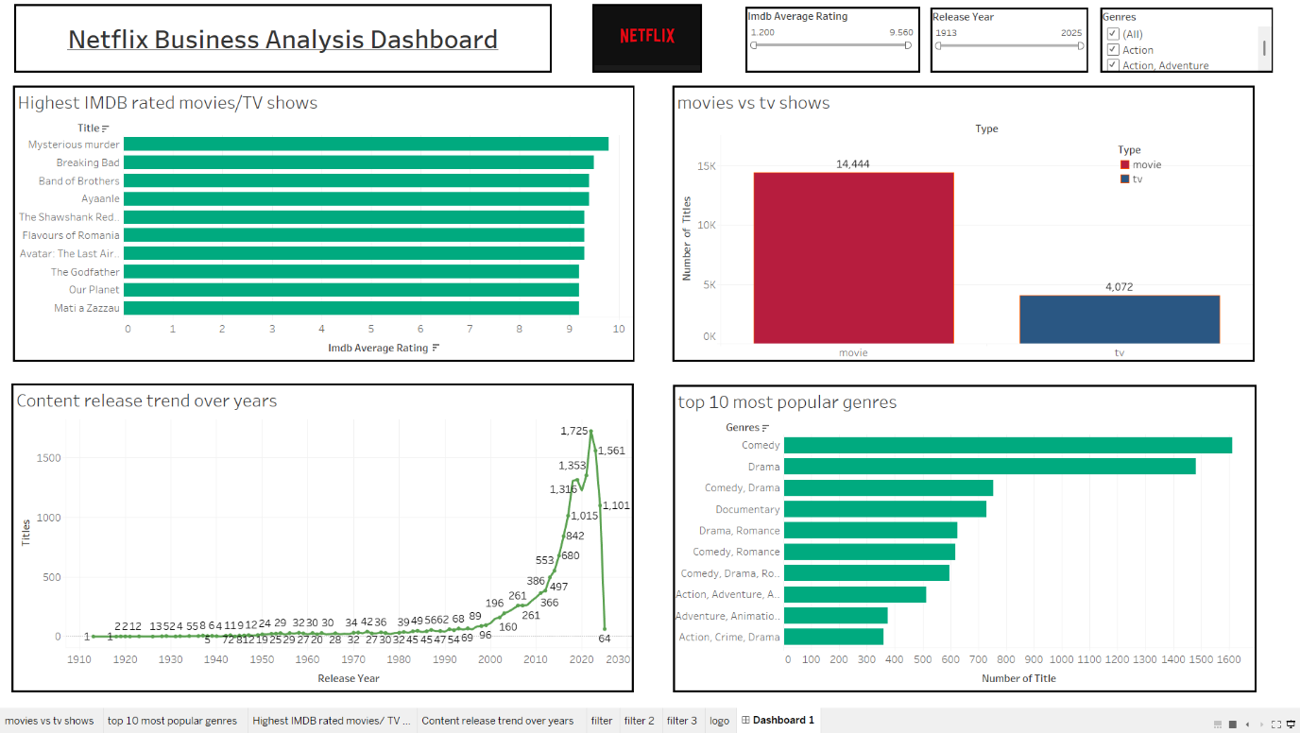

* **Python IDLE Data Preprocessing Code Snippets**

